Q1: Create a stored procedure called uspcountriesasia to list out all the countries with continentid equal to 1, in alphabetical order

CREATE or alter PROCEDURE usp_CountriesAsia

AS

BEGIN

SET NOCOUNT ON;

select CountryName from tblcountry where continentId=1 order by countryname asc ;

END

exec [dbo].[usp_CountriesAsia ];

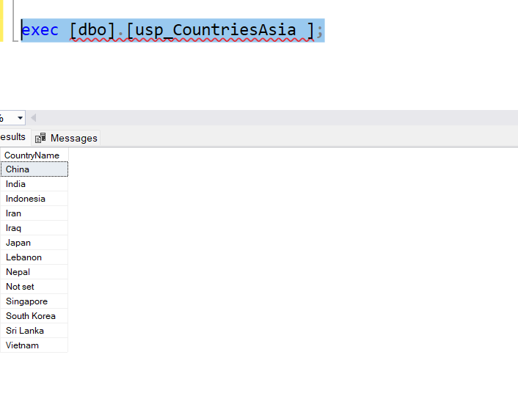

Q2:Modify the text of your query to create a different procedure called uspcountrieseurope which lists all the countries in continent id number 3

CREATE or alter PROCEDURE usp_countries_europe

AS

BEGIN

SET NOCOUNT ON;

SELECT CountryName from tblcountry where continentId=3

END

GO

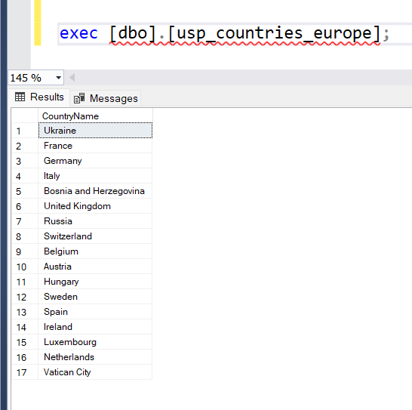

Q3: change the procedure in Q2 so that it list out the countryid also

CREATE or alter PROCEDURE usp_countries_europe

AS

BEGIN

SET NOCOUNT ON;

SELECT CountryName,countryid from tblcountry where continentId=3

END

GO

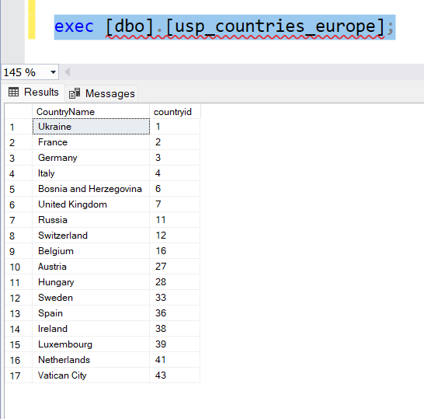

Q4:create a function for Q1

CREATE or alter FUNCTION udf_countriesasia

(

)

RETURNS TABLE

AS

RETURN

(

SELECT CountryName from tblcountry where continentId=1

)

GO

select * from udf_CountriesAsia()

order by countryname asc;

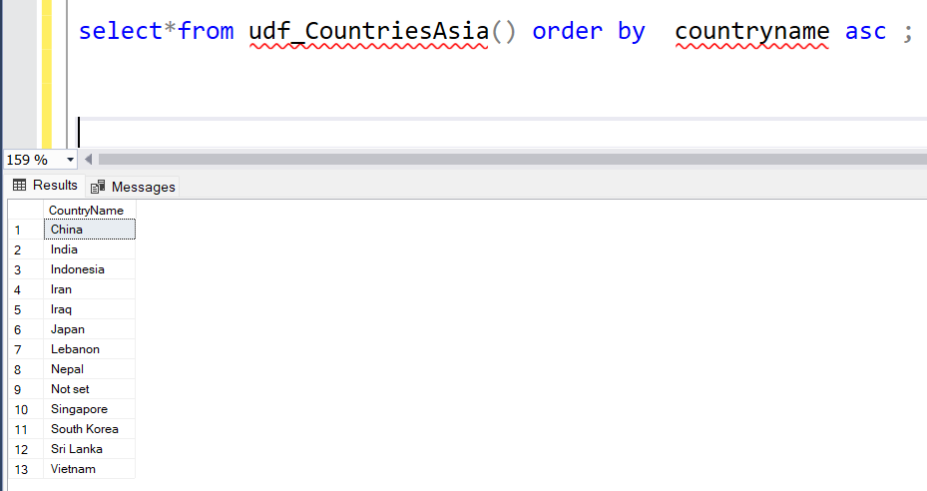

Q5:Convert Q2 into a function

CREATE or alter function udf_countries_europe()

returns table

as

return

(

SELECT CountryName,countryid from tblcountry where continentId=3

)

GO

select * from udf_Countries_europe();

